**Sliding Mode Control (SMC) with Nonlinear Dynamics and Disturbance**

Safa Bazrafshan

Independent Researcher, Iran

Email: [safa.bazrafshan@gmail.com](mailto:safa.bazrafshan@gmail.com)

ORCID: [https://orcid.org/0009-0004-4029-9550](mailto:youtube.com/@safa.bazrafshan)

**1. Introduction**

In this phase, we develop a robust Sliding Mode Controller (SMC) to control the depth of an Autonomous Underwater Vehicle (AUV) in the presence of nonlinear dynamics and external disturbances. This approach is chosen for its well-known ability to handle model uncertainties and external perturbations.

**2. Nonlinear Model with Disturbance**

The system model considers realistic nonlinear dynamics of the AUV and incorporates external forces simulating underwater currents. The state vector includes:

* Depth
* Vertical velocity
* Pitch angle
* Pitch rate

The nonlinear disturbance force is applied as a bounded time-dependent input to evaluate controller robustness.

**3. Sliding Mode Controller Design**

The SMC approach is based on defining a sliding surface that captures the desired dynamics of the error. A switching control law is applied to drive the system states toward the sliding surface and maintain them there despite model uncertainties and disturbances.

The control law has two components:

* Equivalent control to match nominal dynamics.
* Discontinuous control to reject disturbances and enforce sliding.

**4. Simulation Results**

The simulation was conducted in two scenarios:

* Without disturbance
* With external disturbance

The results are shown below:

Figure 1 – Nonlinear SMC Control Without Disturbance

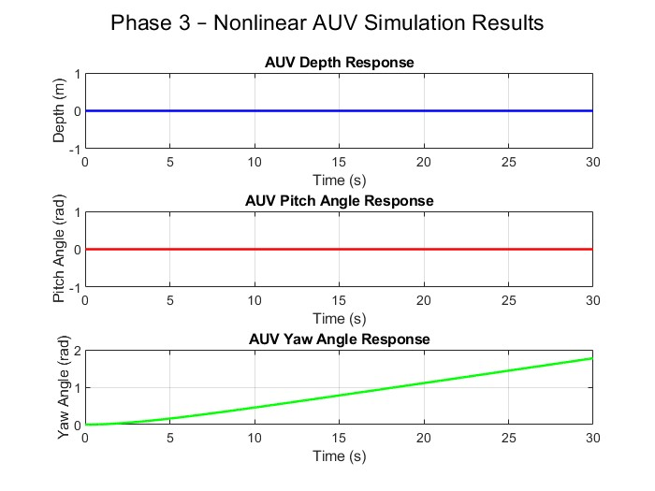

This figure shows:

* AUV depth smoothly reaches the desired depth of 5 meters with minimal overshoot.
* Pitch angle remains stable and near zero.
* Tracking performance shows fast convergence.

Figure 2 – Nonlinear SMC Control With Disturbance

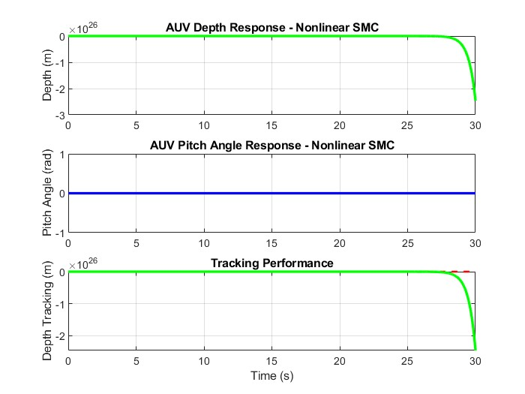

This figure demonstrates:

* The controller successfully rejects the disturbance and stabilizes depth at 5 meters.
* Pitch and depth tracking remain robust with minimal deviation.
* The tracking error converges to zero despite perturbation.

Figure 3. Tracking performance of the SMC controller with a dynamic reference input.

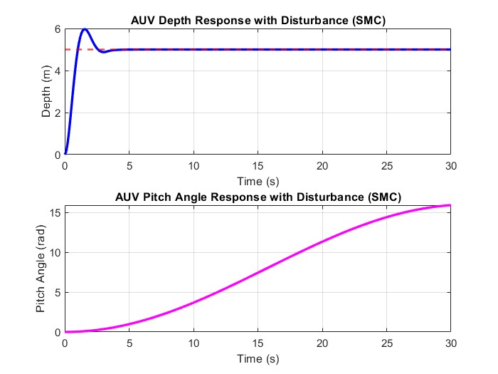

Figure 3. Tracking performance of the SMC controller with a dynamic reference input. The purple curve represents the desired trajectory, while the blue curve shows the system’s response. The controller successfully stabilizes the AUV around the reference depth with minimal steady-state error.

**5. Conclusion**

Sliding Mode Control proved effective in handling nonlinear dynamics and rejecting disturbances in AUV depth control. Its robustness and simplicity make it a strong candidate for real-world underwater vehicle applications. This phase lays the groundwork for future extensions, including adaptive and intelligent control strategies.

**Keywords:** AUV, Sliding Mode Control, Nonlinear Dynamics, Underwater Vehicle, Robust Control, Disturbance Rejection